**Digitalmonks.ca - Website Design Edits**

1. **Menu Bar**
   1. Mobile - Change Burger Menu to the left & Add “Let's Talk” CTA on the right. DM.ca(Digital monk) logo in the centre
2. **Carousel Banner** 
   1. Make a duplicate slider for the mobile view (only visible in mobile resolutions) and use a single image which are mobile resolutions oriented
   2. Can we add a carousel counter (See the image below)

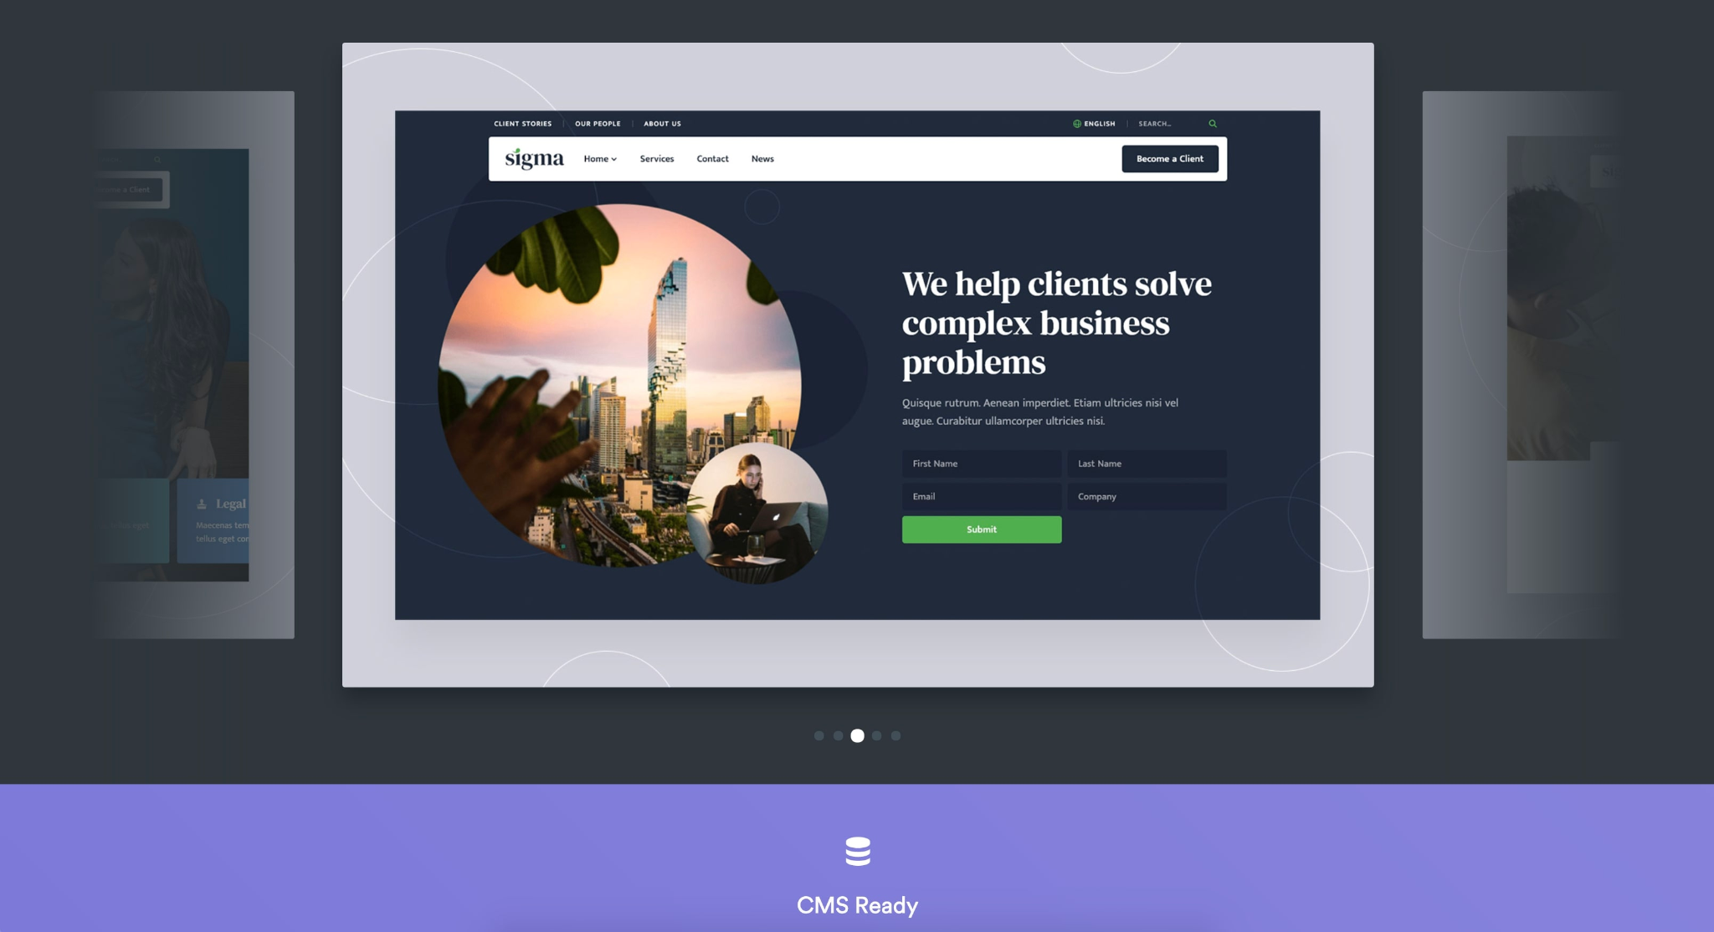

To get carousel counter Check wheather we can use this slider or not : https://ui-themez.smartinnovates.net/items/geekfolio/light/showcase-parallax-slider.html

1. **Services Section**
   1. **Use this section for service listing**

[**https://ui-themez.smartinnovates.net/items/geekfolio/light/home-creative-agency.html**](https://ui-themez.smartinnovates.net/items/geekfolio/light/home-creative-agency.html)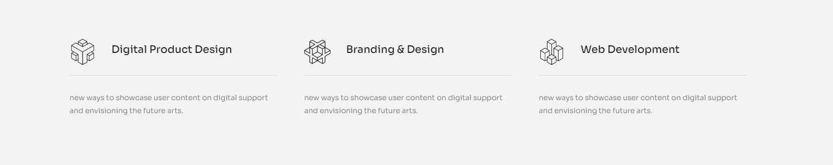

**Or can can we use this testimonials section and modify the cards for service section elements ?**

https://ui-themez.smartinnovates.net/items/geekfolio/light/page-team.html

* 1. Please change Featured Service to “Services”
  2. Change Services Heading to “Empowering you to reach your goals”.
  3. Remove the existing div which contains “Empowering you…..”

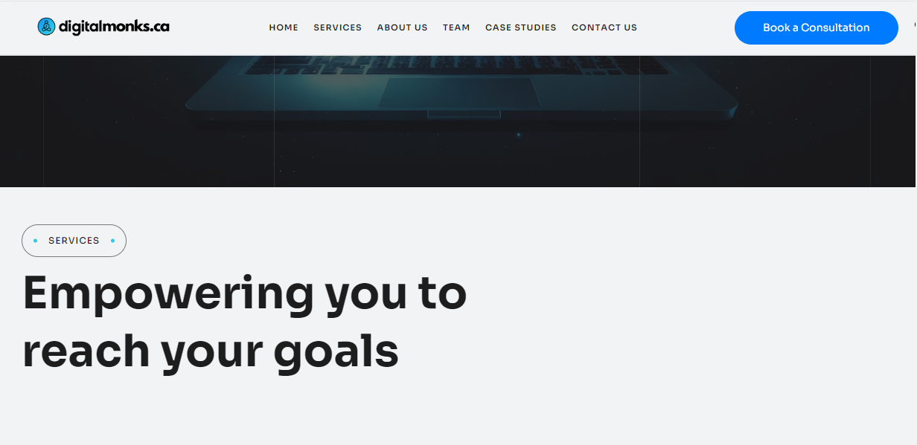

* 1. add a CTA button after the service listing (Get Started)- Contact Page



1. **Packages**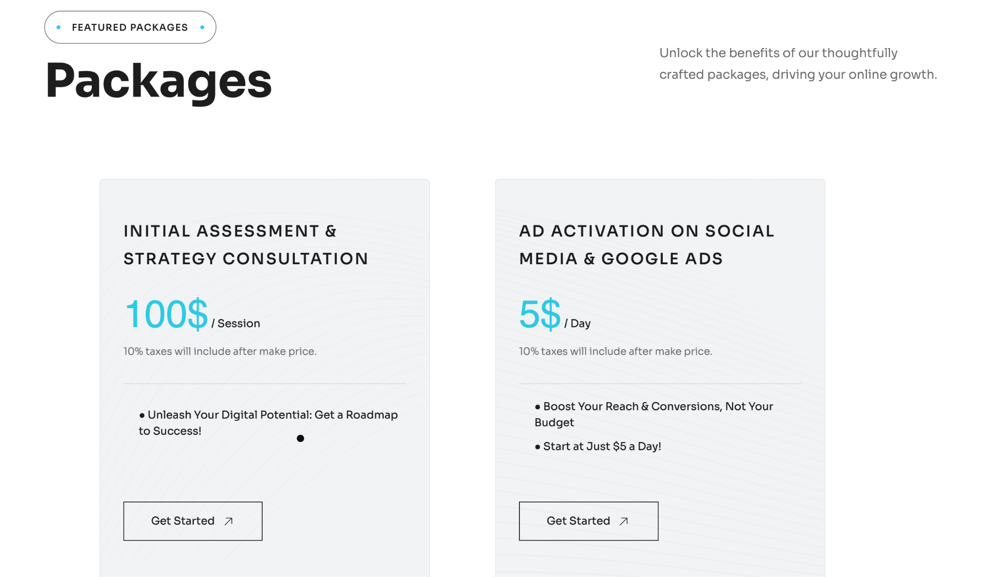
   1. change Featured Packages to Pricing
   2. Change Packages to "Find Your Perfect Package”
   3. Change individual cards with the following content
      1. Initial Assessment & Strategy Consultation
         1. Change 10% taxes to “Most Popular”
         2. Instead of Unleash your

Suitable for:

* Businesses seeking a winning digital strategy
* Individuals looking to maximize their online presence
* Organizations in need of effective digital marketing guidance
  + 1. Ad Activation on Social
       1. Change 10% taxes to “Best Seller”

Suitable for:

* Small businesses with a limited advertising budget
* Startups looking to establish their online presence
* Entrepreneurs seeking cost-effective advertising solutions
  + 1. CONTENT CREATION FOR ANY MARKETING SERVICES
       1. Change 10% taxes to “Customer Favourite’

Suitable for:

* Businesses of all sizes in need of marketing content
* Marketing agencies seeking reliable content creation support
* Entrepreneurs looking for flexible content solutions
  + 1. WEBSITE CONSULTATION & WEBSITE BUILDING
       1. Change 10% taxes to “Top Choice”

Suitable for

* + - * 1. Small businesses and startups in need of professional website consultation
        2. Individuals or organizations looking to build their online presence
        3. Entrepreneurs seeking affordable and customizable website solutions

1. Add Frequently Asked Questions section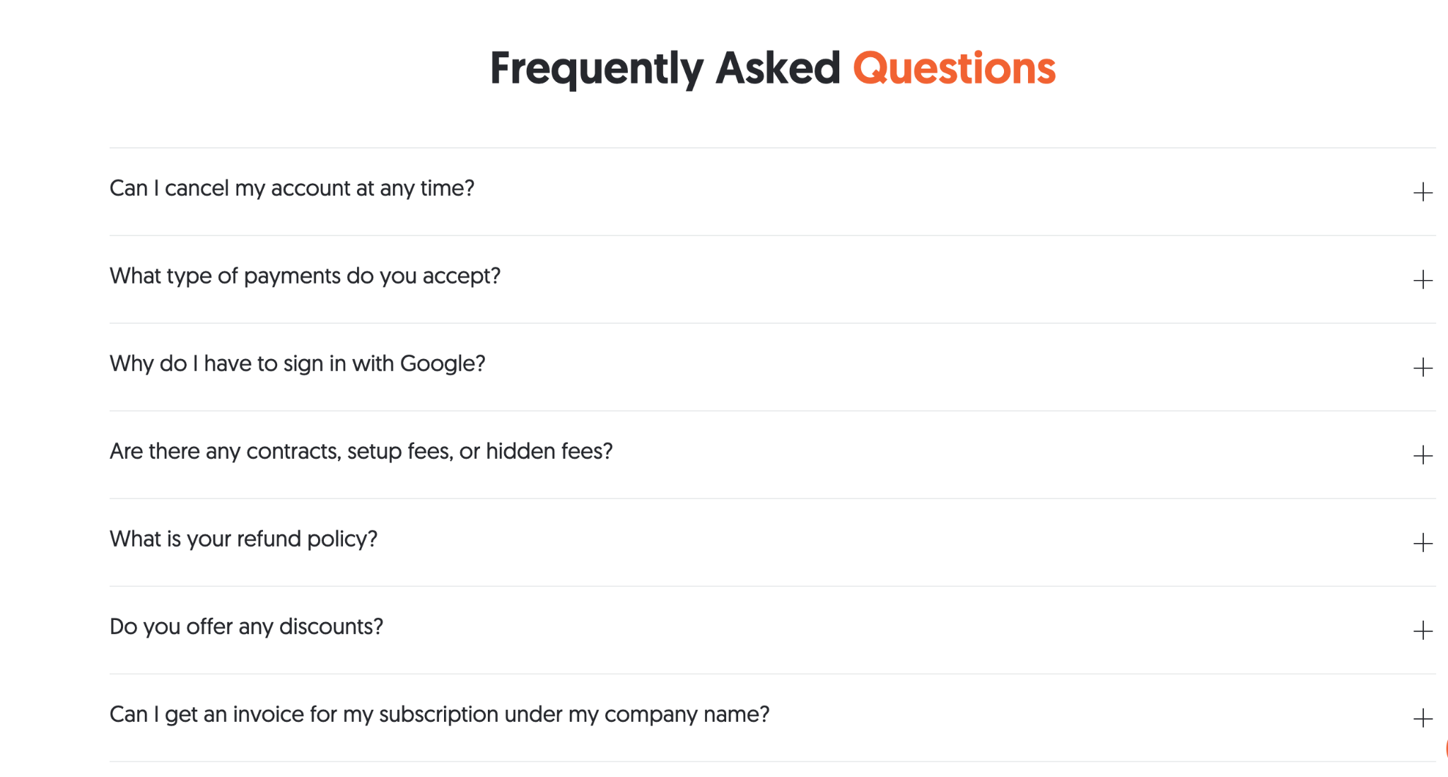
2. Add a logo section with meta, DV360, CM360, linkedin, google ads, twitter, youtube with heading “Target. Reach. Convert.”

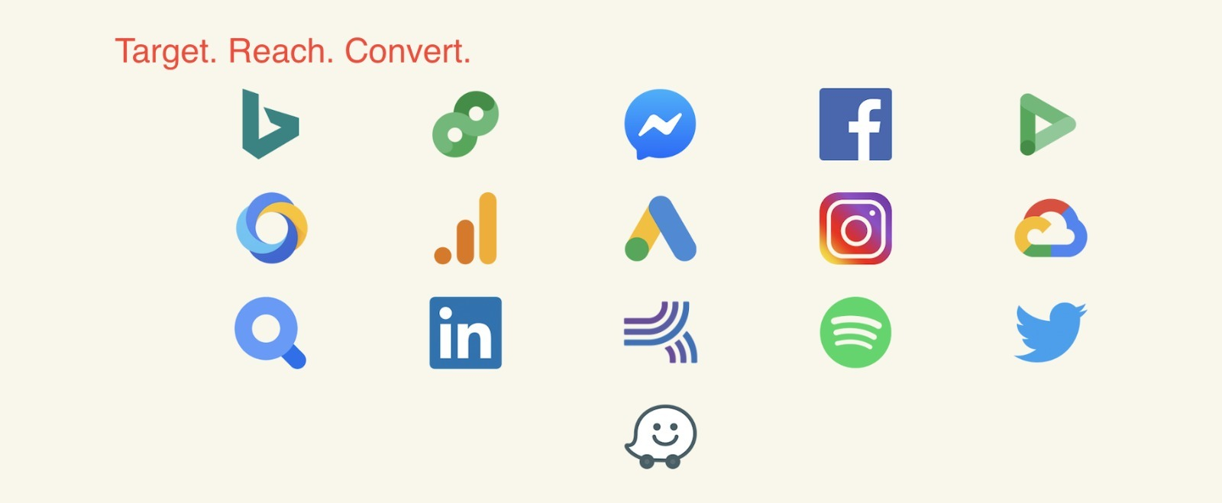

1. About US
   1. Align to full justify and add space between paragraph
   2. Remove Marketing strategy, Unique production etc..
2. Replace that small logo with Digitalmonks.ca blue symbol logo without text
3. Remove Our Staff and change Talented Team to “Discover Our Dynamic Team”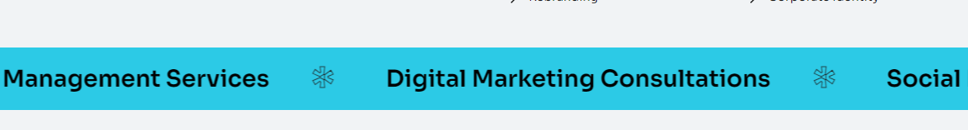
4. Let's Discuss to Lets’Connect
5. Footer

Use only one column for Contact us

* 1. Contact Us:
     1. Email: info.digitalmonks.ca
     2. Phone: +1(437) 887 4691
     3. Address: 268 Matheson Blvd E #102, Mississauga, ON L4W 0A5
  2. Change Social to Follow Us
     1. And Use logos for social platforms
        1. Currently, Use only Instagram

1. Add a Privacy policy page with the following content

PRIVACY POLICY:

Privacy Policy for Digital Monks

Last updated: [Date]

This Privacy Policy outlines how Digital Monks ("we," "us," or "our") collects, uses, discloses, and protects the personal information of users ("you" or "your") on the website digitalmonks.ca ("Website"). We are committed to protecting your privacy and complying with Canadian privacy laws, including the Personal Information Protection and Electronic Documents Act (PIPEDA) and applicable provincial privacy legislation.

Information We Collect:

We may collect personal information from you when you visit or interact with our Website. The types of personal information we may collect include:

* Name, email address, and contact information provided voluntarily when you fill out forms or contact us through the Website.
* Usage information, such as IP address, browser type, device information, and browsing activities, collected automatically through cookies and similar technologies.

Use of Personal Information:

We may use your personal information for the following purposes:

* To provide and improve our services, including responding to your inquiries and fulfilling your requests.
* To personalize your experience on our Website and deliver relevant content.
* To communicate with you, send you updates, newsletters, and promotional materials, with your consent where required.
* To analyze and monitor the usage of our Website, perform data analytics, and improve our marketing strategies.

Disclosure of Personal Information:

We may disclose your personal information in the following circumstances:

* With your consent, to third-party service providers who assist us in operating our Website, conducting business activities, or providing services to you.
* As required by law, to comply with legal obligations or respond to lawful requests and legal process.
* In connection with a business transaction, such as a merger, acquisition, or sale of assets, where your personal information may be transferred to the new owners.

Data Retention:

We will retain your personal information only for as long as necessary to fulfill the purposes outlined in this Privacy Policy or as required by law. When your personal information is no longer needed, it will be securely deleted or anonymized.

Security Measures:

We implement appropriate technical and organizational measures to protect your personal information against unauthorized access, disclosure, alteration, or destruction. However, no data transmission or storage system can be guaranteed to be 100% secure.

Your Privacy Rights:

You have the right to access, update, correct, and delete your personal information held by us. If you wish to exercise these rights or have any privacy-related concerns, please contact us using the information provided below.

Third-Party Links:

Our Website may contain links to third-party websites or services. We are not responsible for the privacy practices or content of such third parties. We encourage you to read the privacy policies of those websites before providing any personal information.

Changes to the Privacy Policy:

We may update this Privacy Policy from time to time. The updated version will be posted on our Website with the revised "Last updated" date. We recommend reviewing this Privacy Policy periodically to stay informed about how we collect, use, and protect your personal information.

Contact Us:

If you have any questions, concerns, or requests regarding this Privacy Policy or our privacy practices, please contact us at:

Email : info.digitalmonks.ca

By using our Website, you acknowledge that you have read, understood, and agreed to the terms of this Privacy Policy.